Before running the selenium project in Jenkins, make sure the following:

1. Maven should be installed on your system.
2. Make sure eclipse project is running locally from maven:

Make sure suite xml file is setup correctly in pom.xml 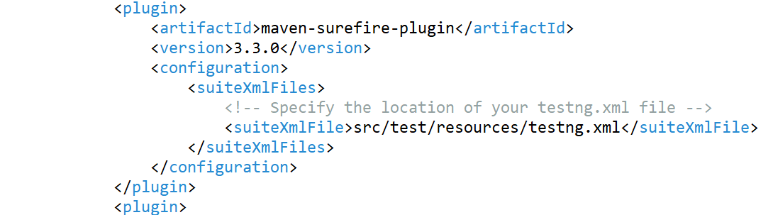

Scope for testng dependency should be compile

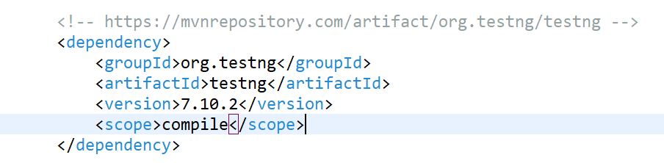

Before Jenkins setup, make sure your project is running locally from maven

1. Right click on the project🡪 Run As🡪 Maven clean

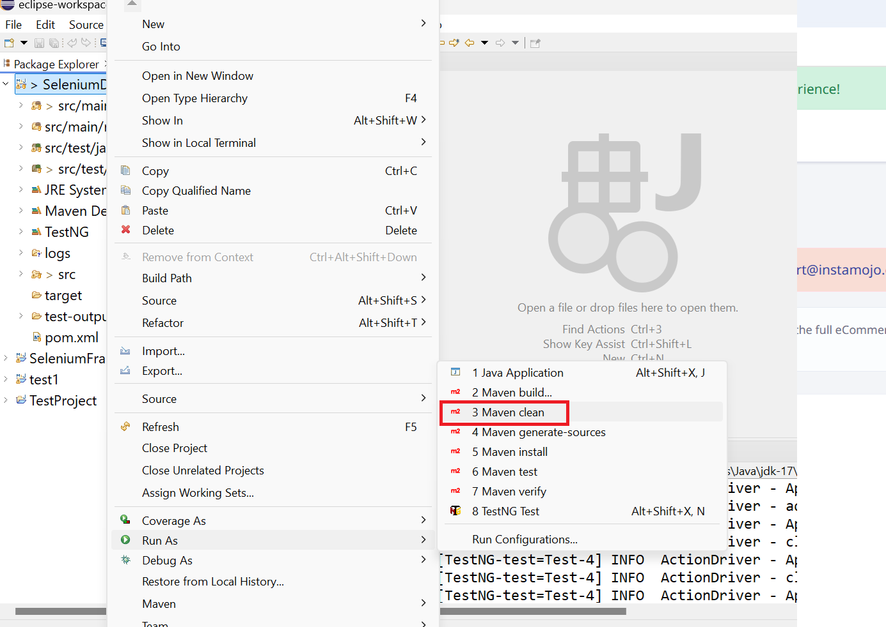

1. Should be build success

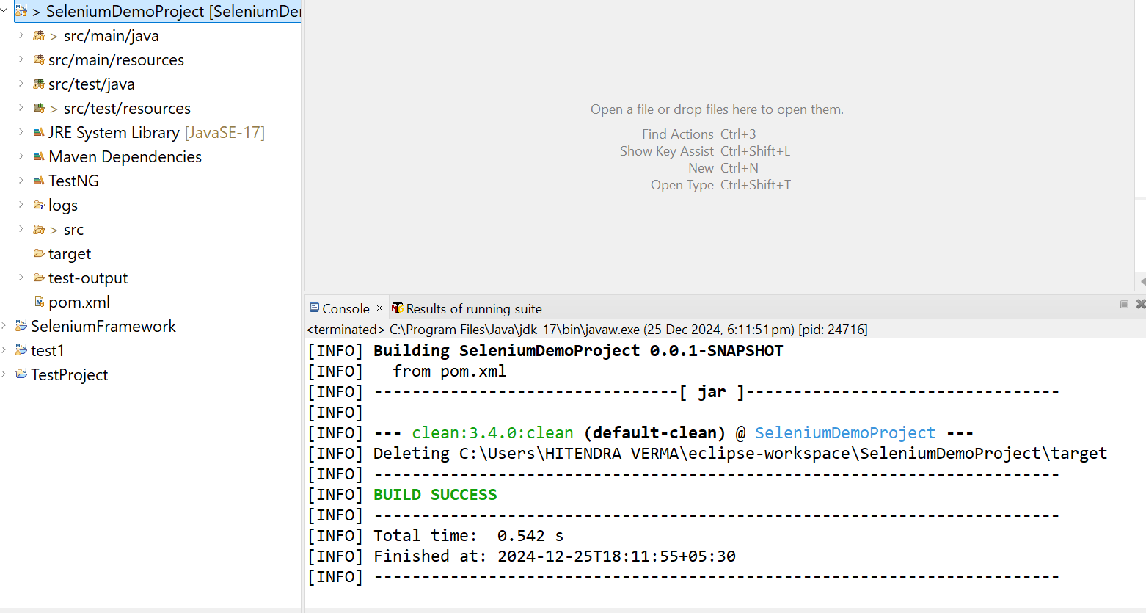

1. Right click on the project🡪 Run As🡪 Maven install

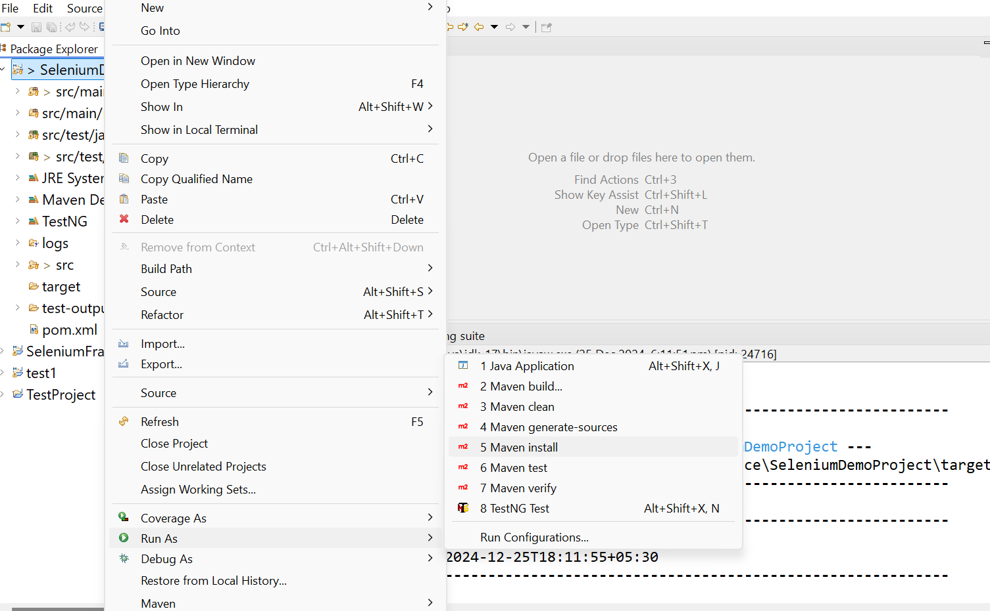

1. Should be Build success

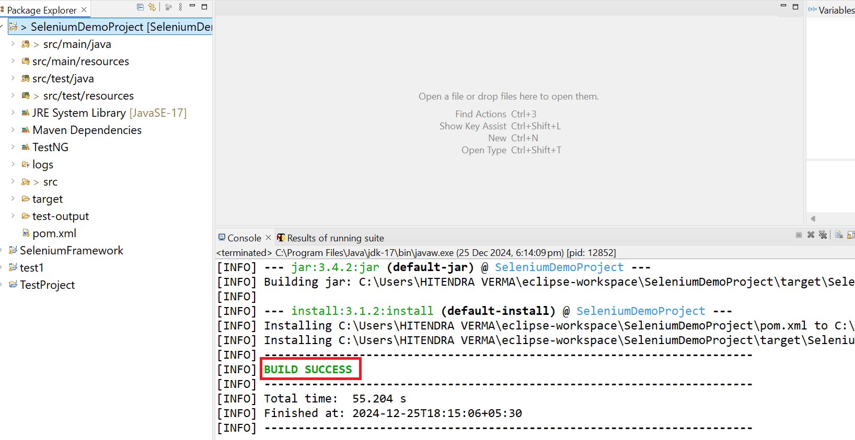

1. Now follow the below steps to setup build in jenkins
2. Download Jenkins from below link

<https://www.jenkins.io/download/>

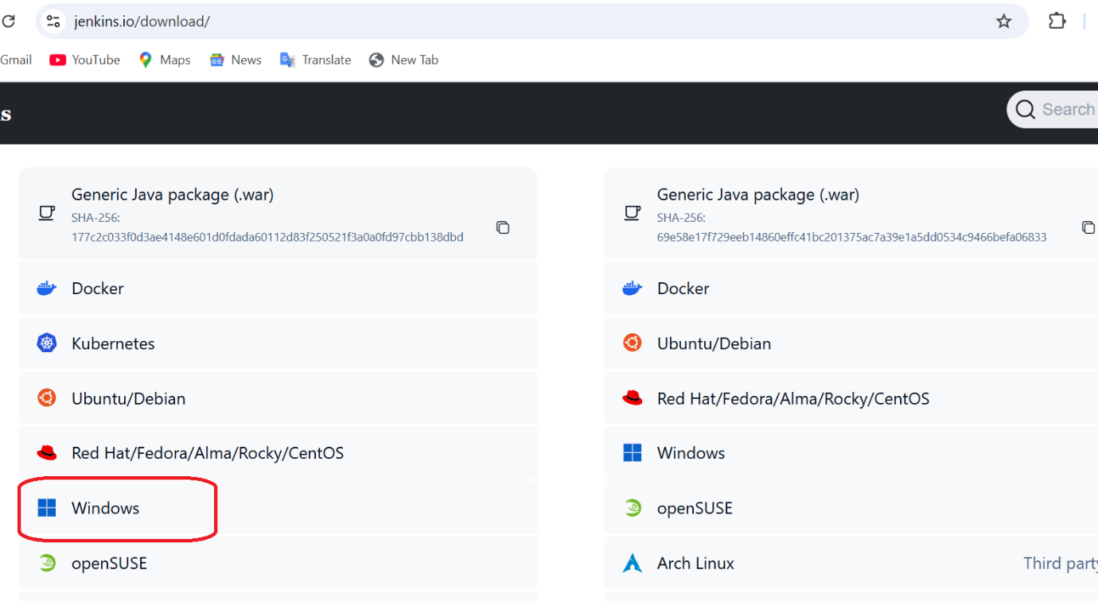

1. Now click on the windows installer package

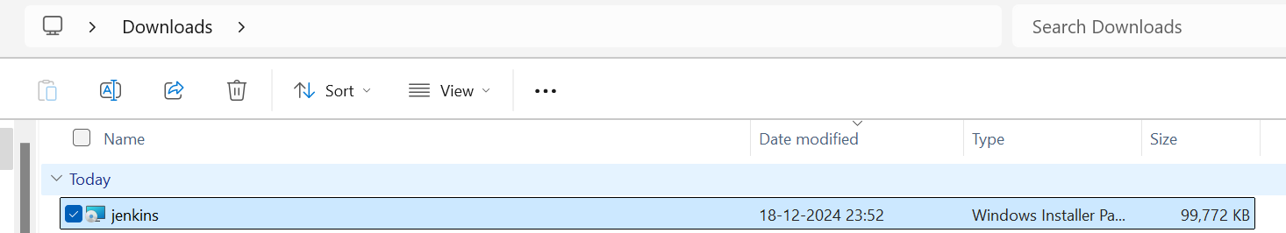

1. Install the Jenkins as per below instructions/screenshots

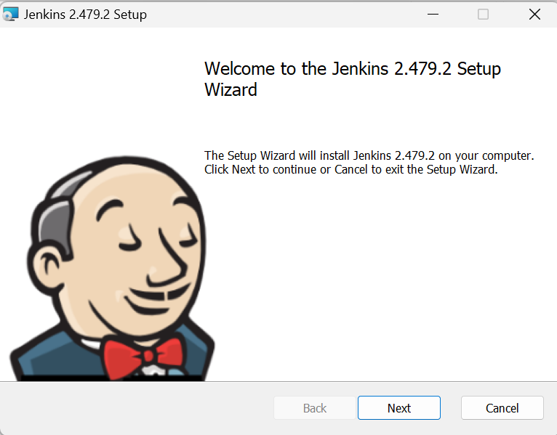

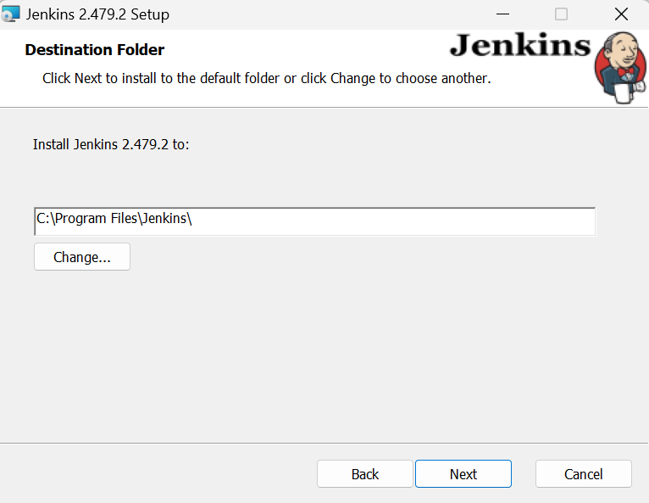

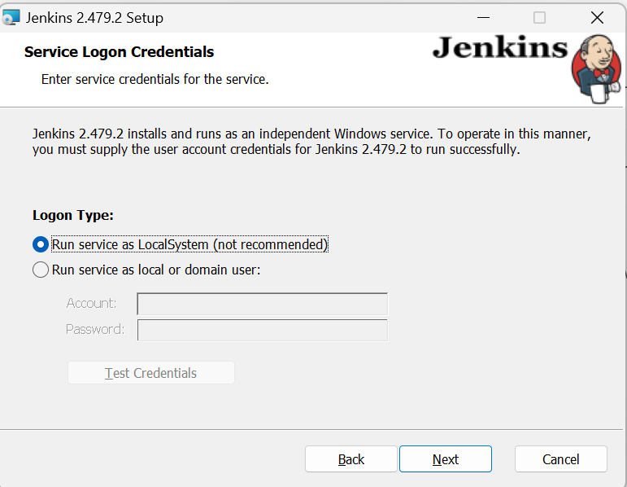

1. Click Test Port button

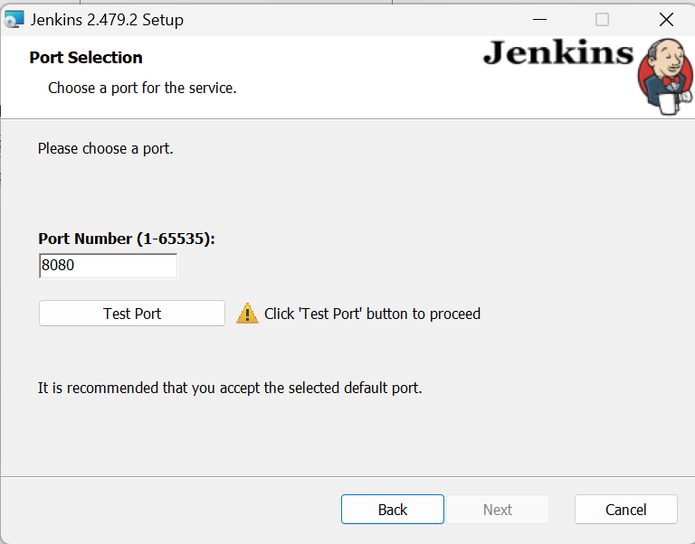

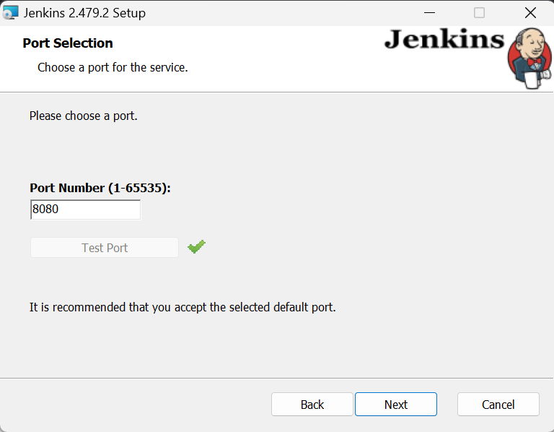

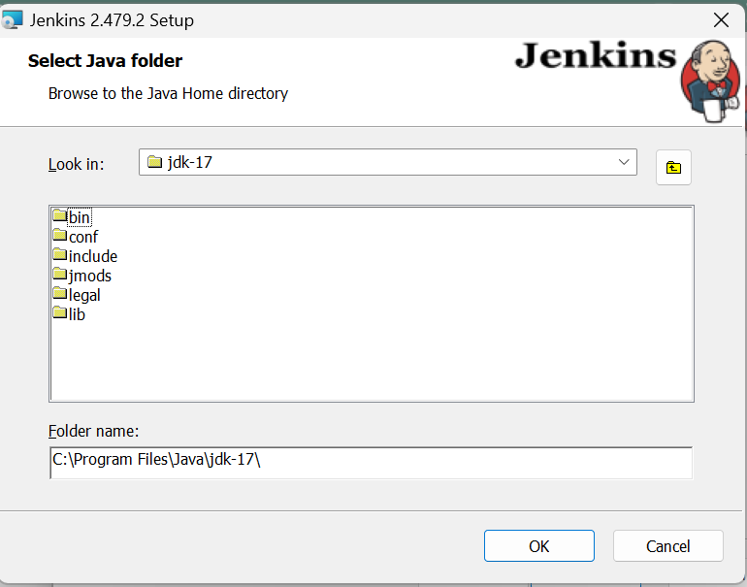

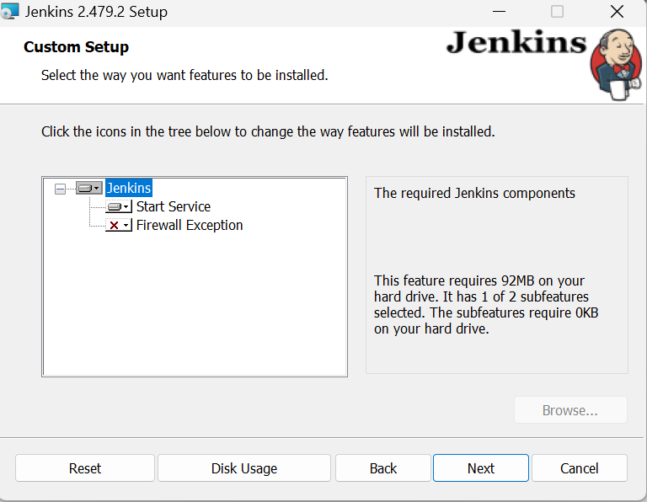

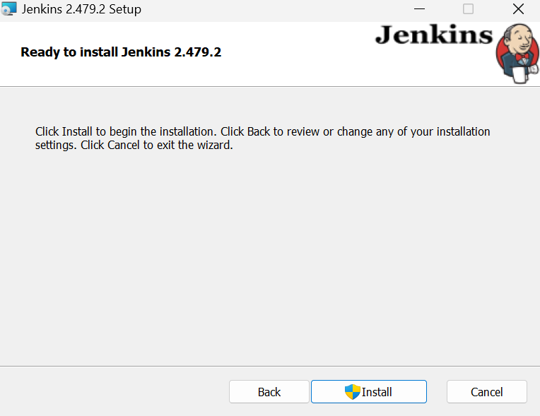

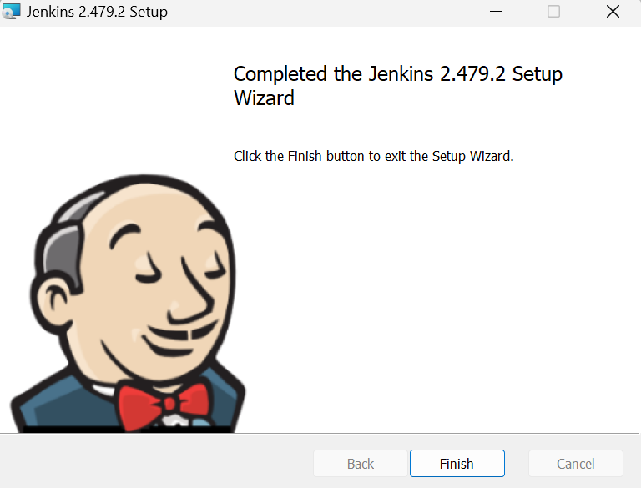

1. Enter your initial admin password located in given path

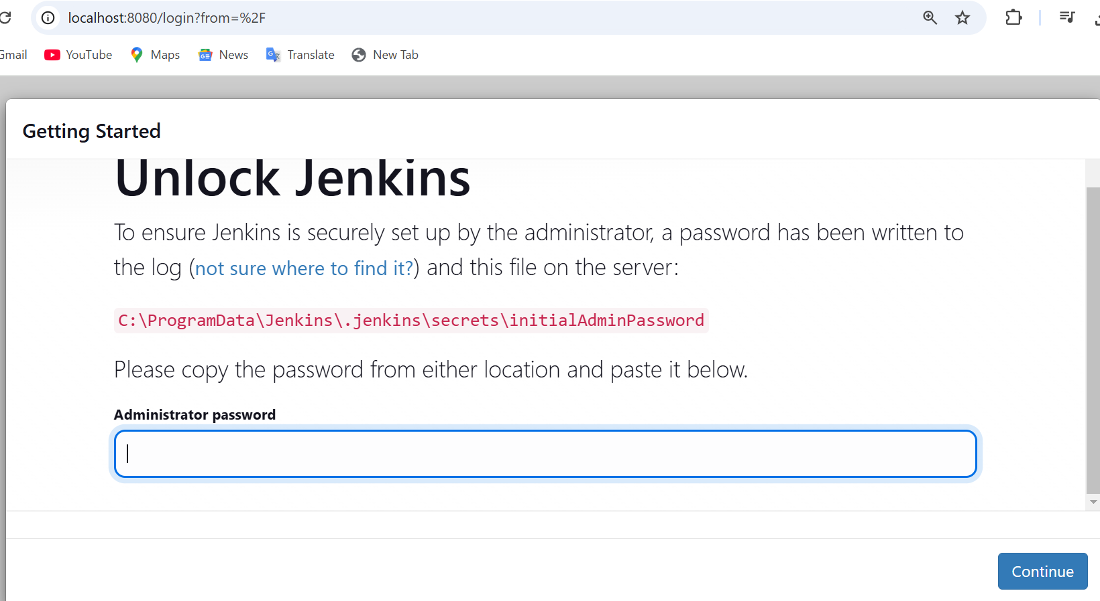

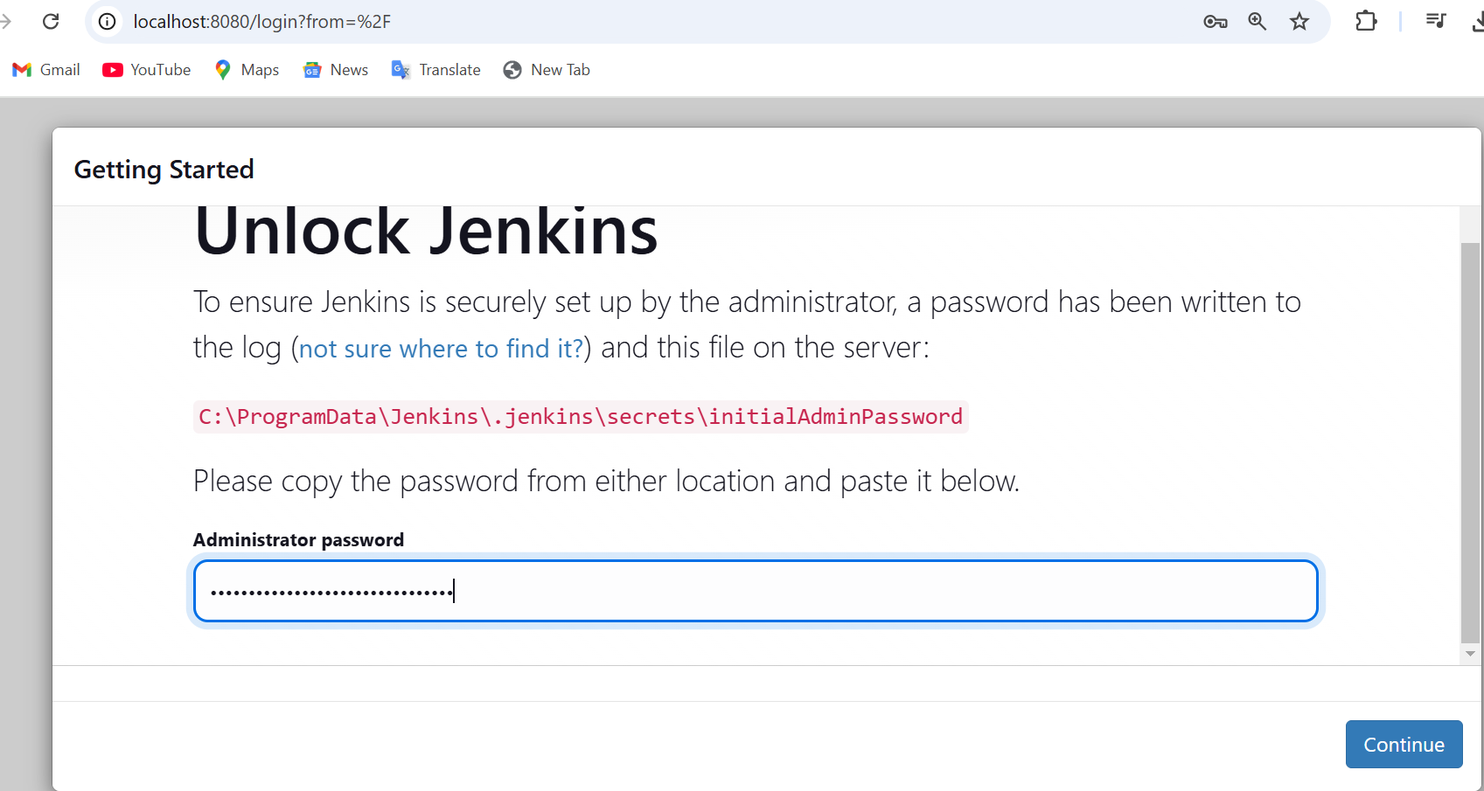

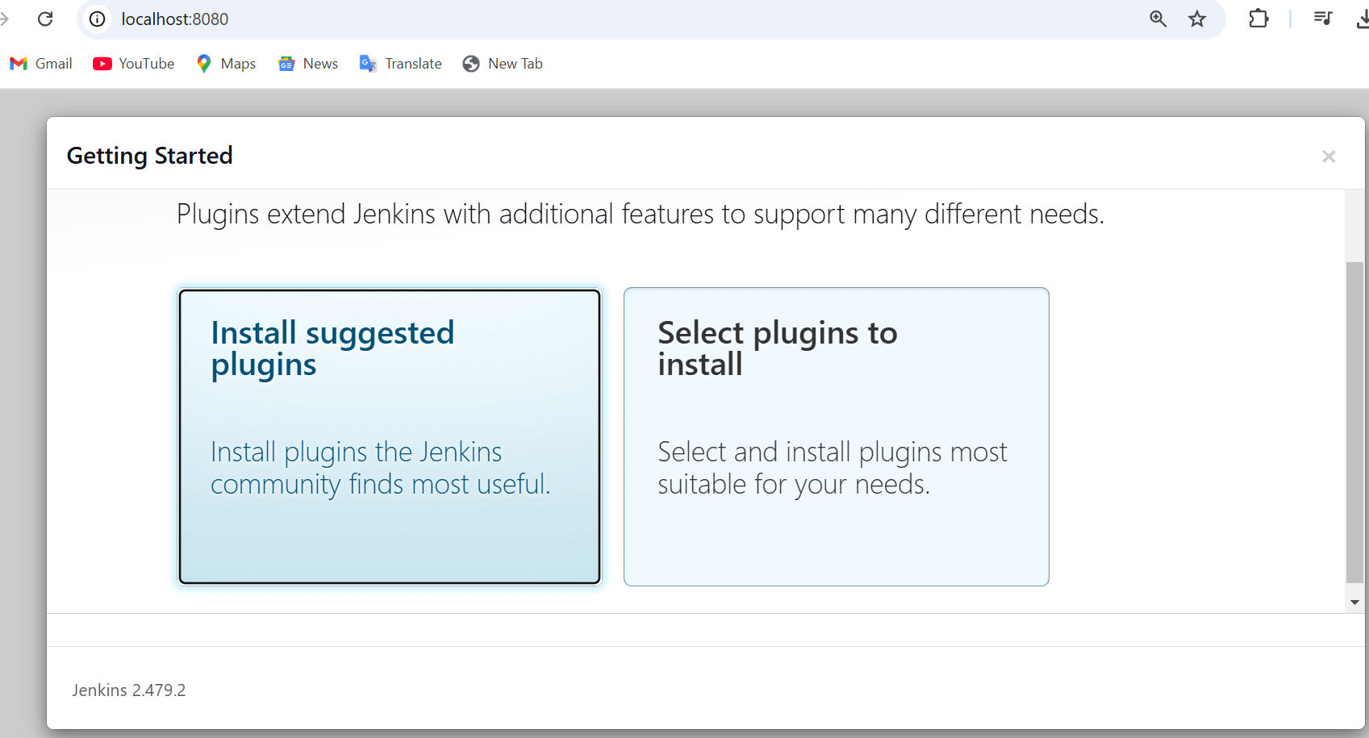

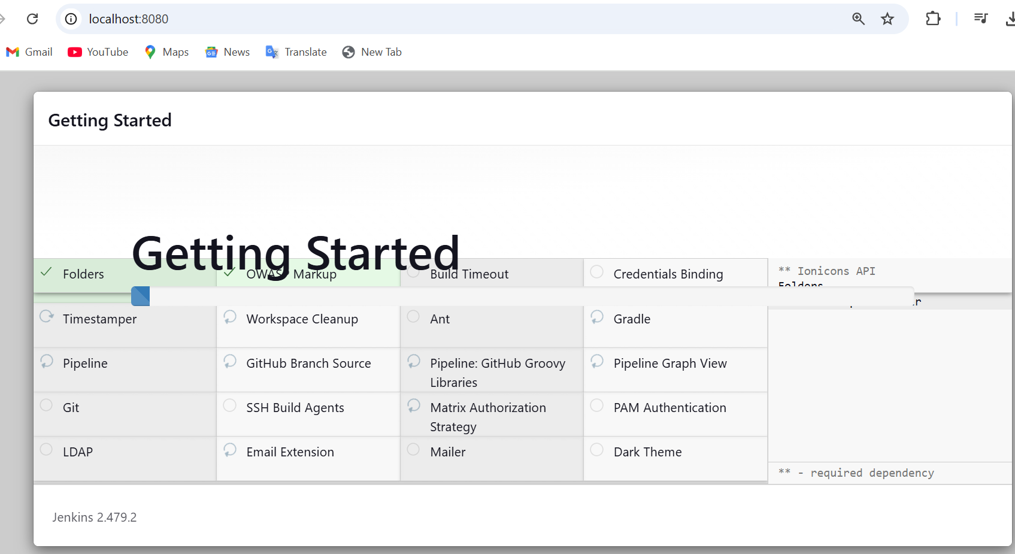

1. Create your admin user

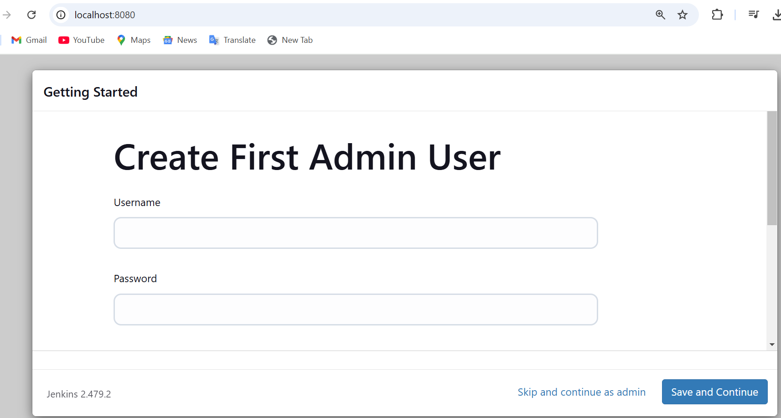

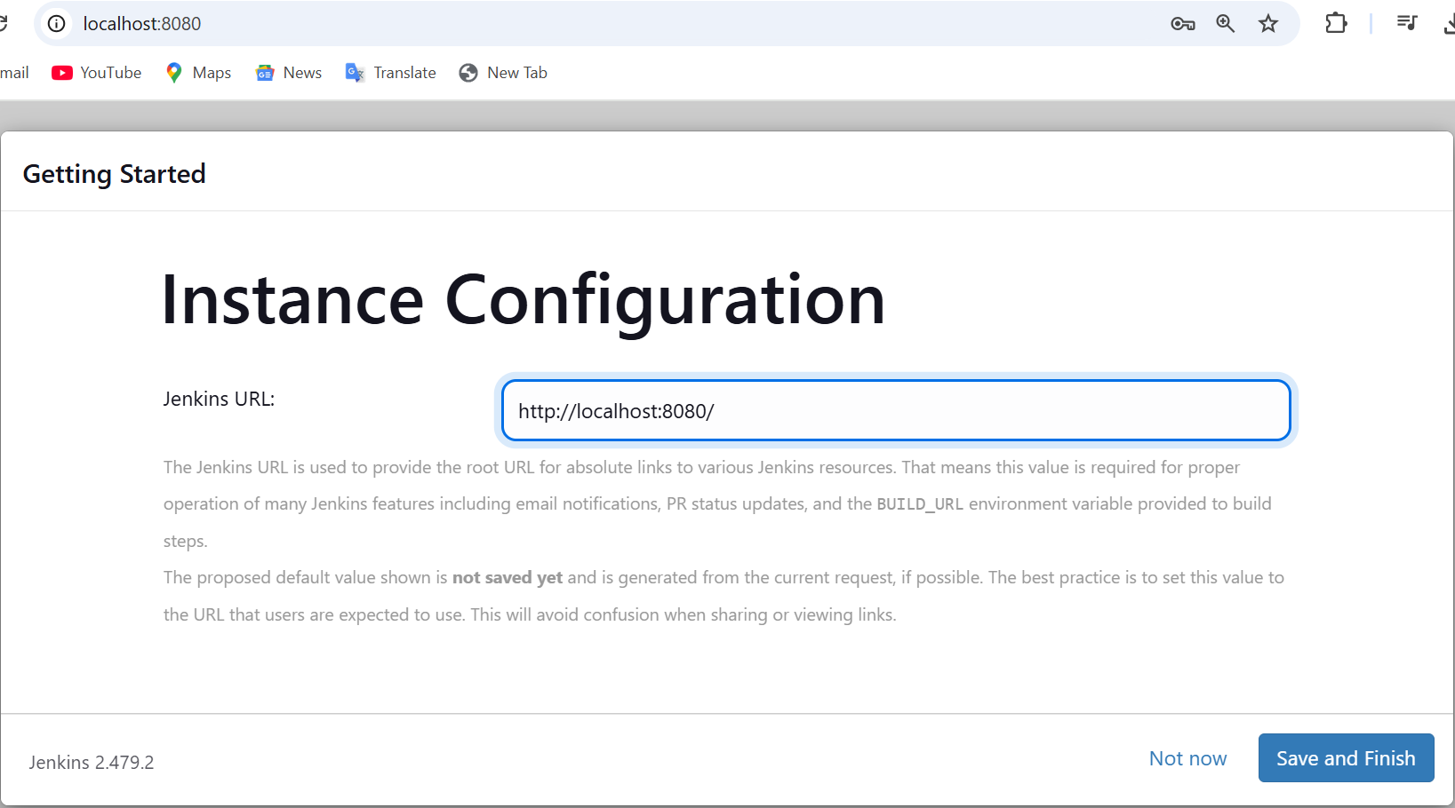

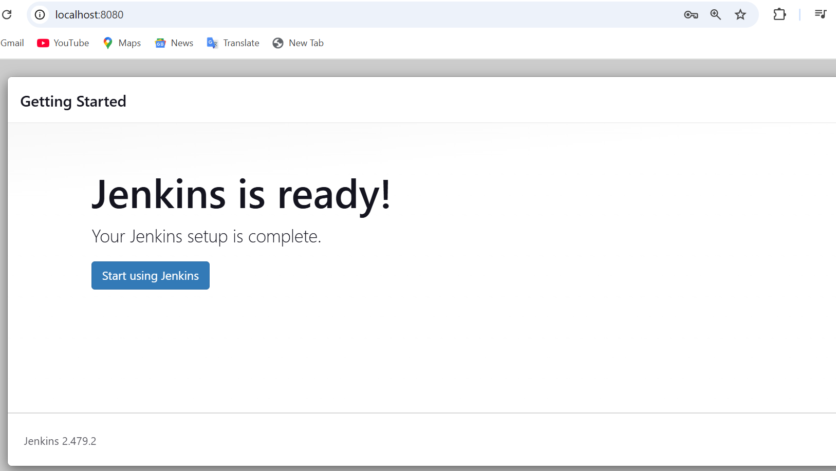

1. Add required plugins - like HTML reporter

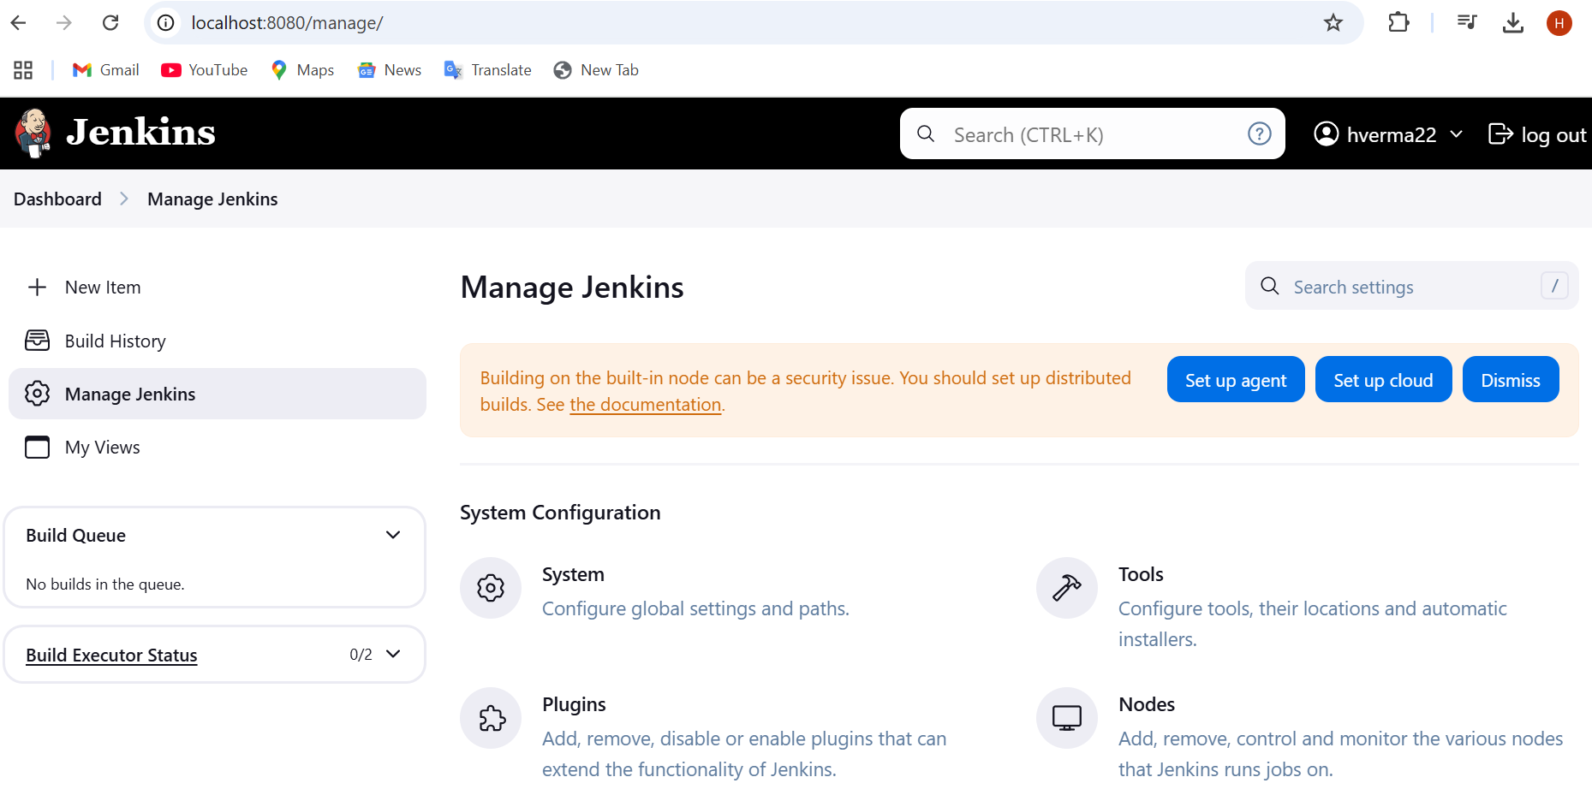

1. Create Jenkins job

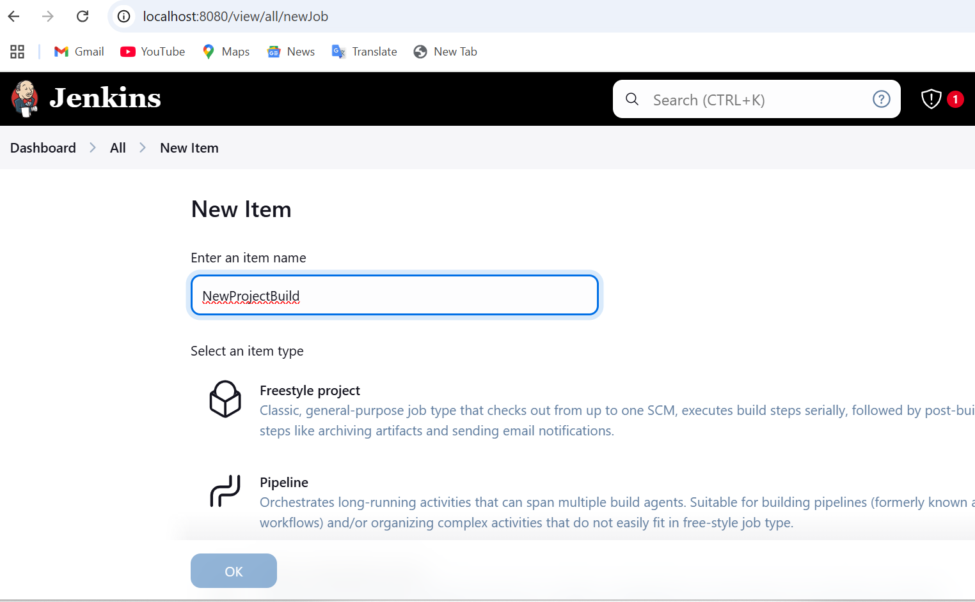

1. Run the selenium script in Jenkins - Select freestyle project

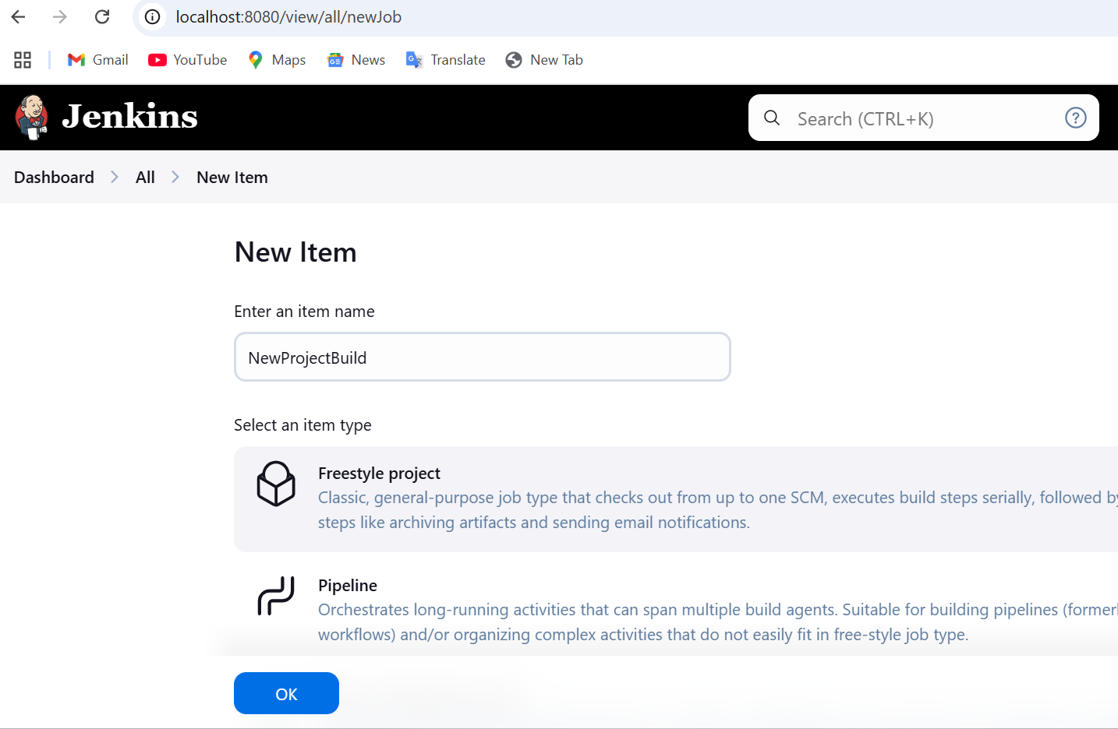

Configure the project

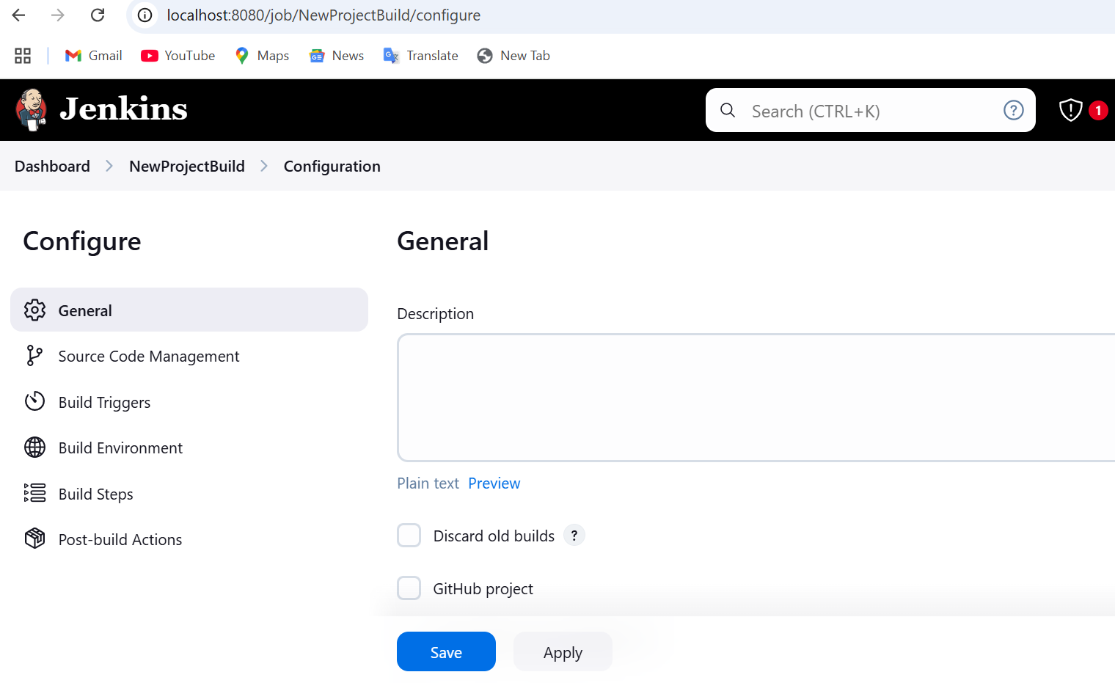

Select source code management as git and put your github repo url

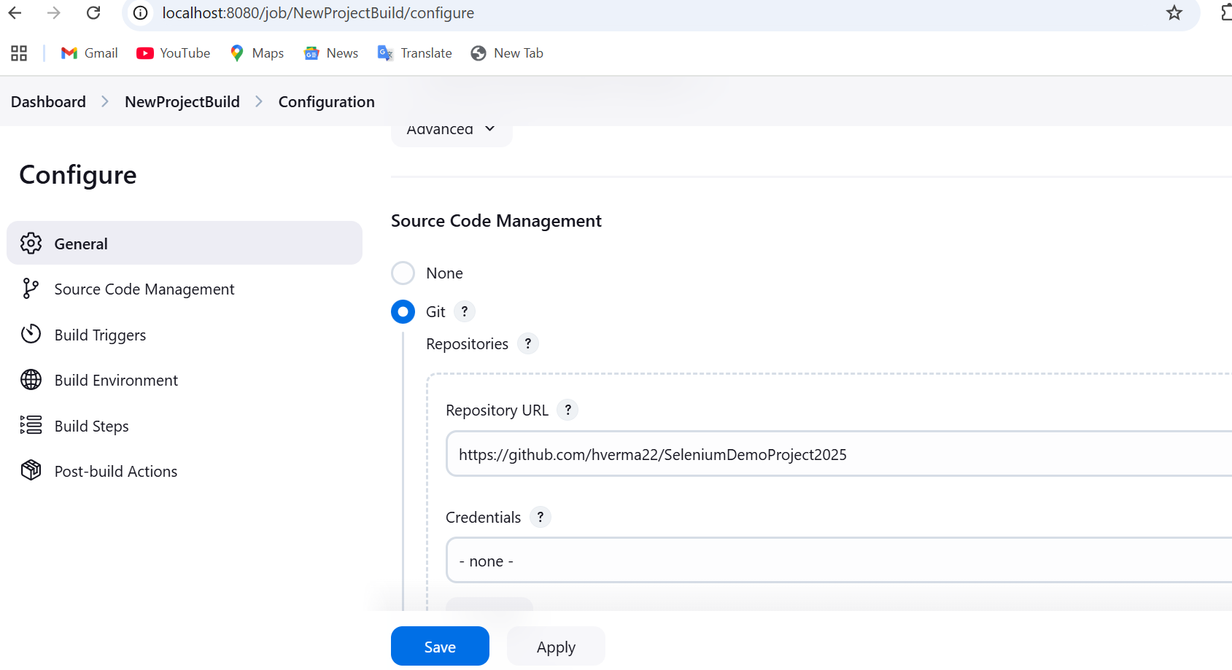

Select/enter github credentials (not required if your repository is public)

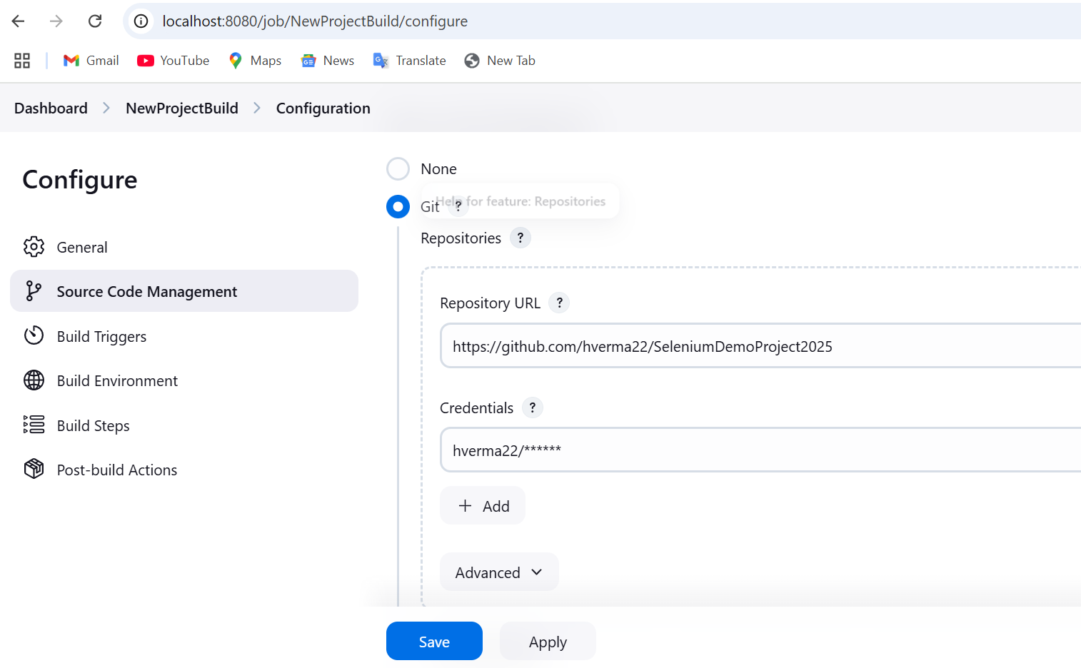

Add build steps

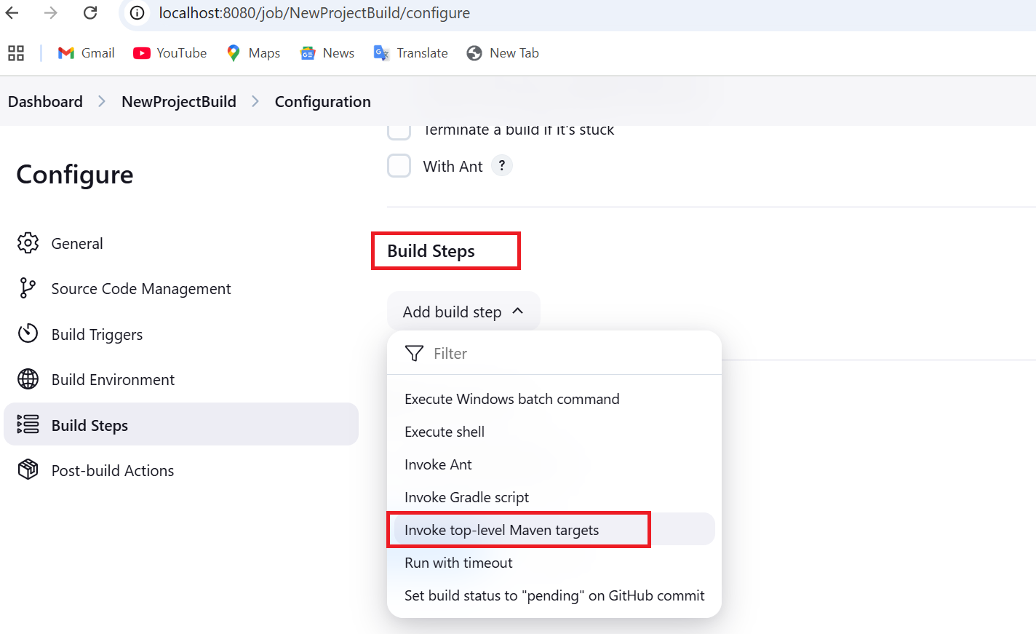

Enter maven version and goals

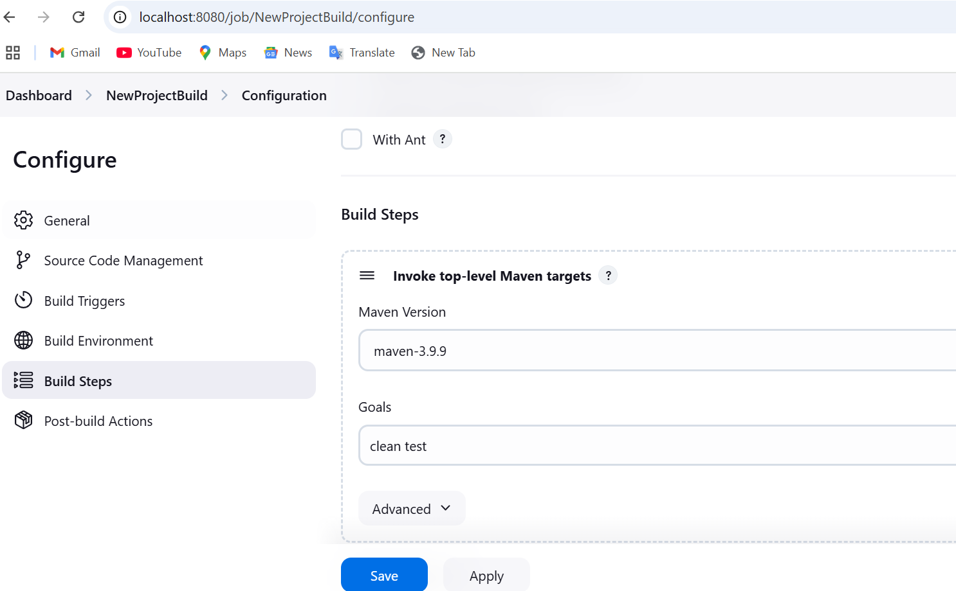

Add post build Actions, select HTML reports

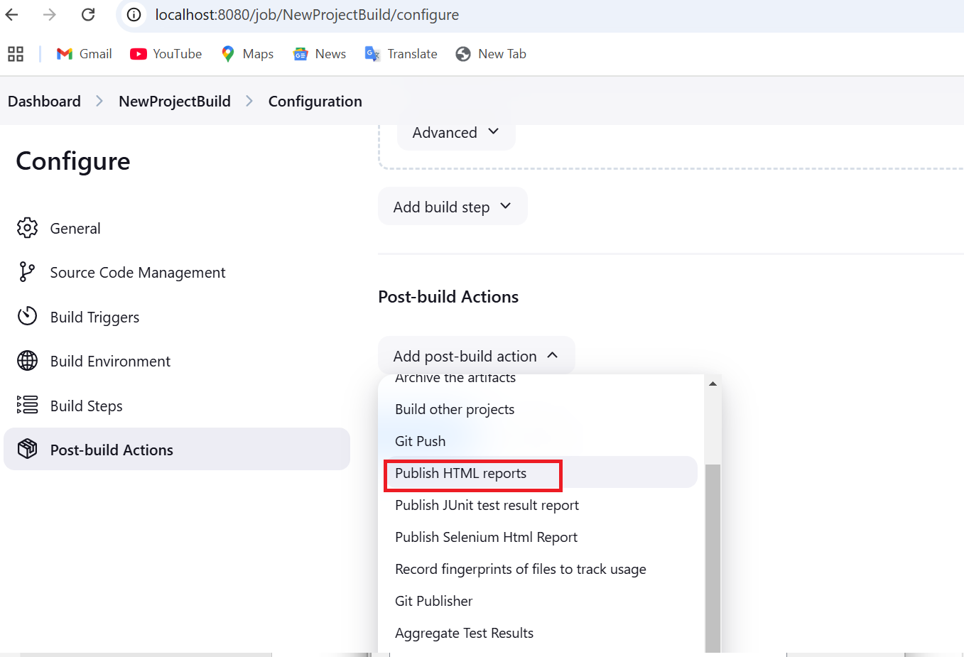

Enter below details for the reports

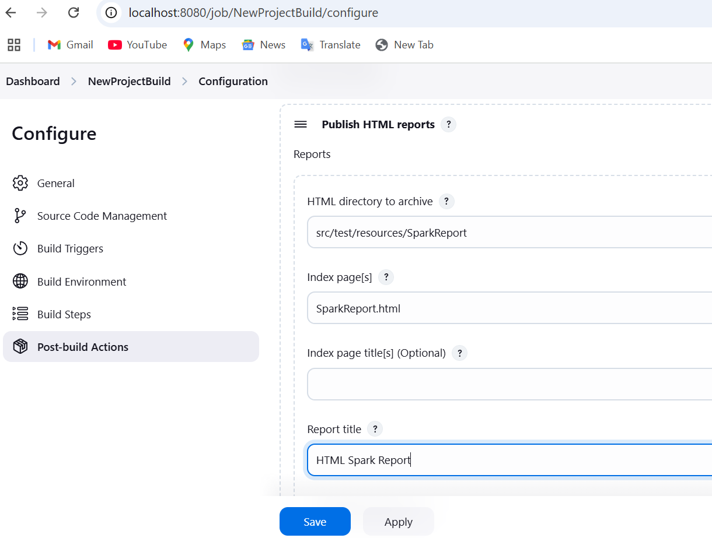

Now build the project

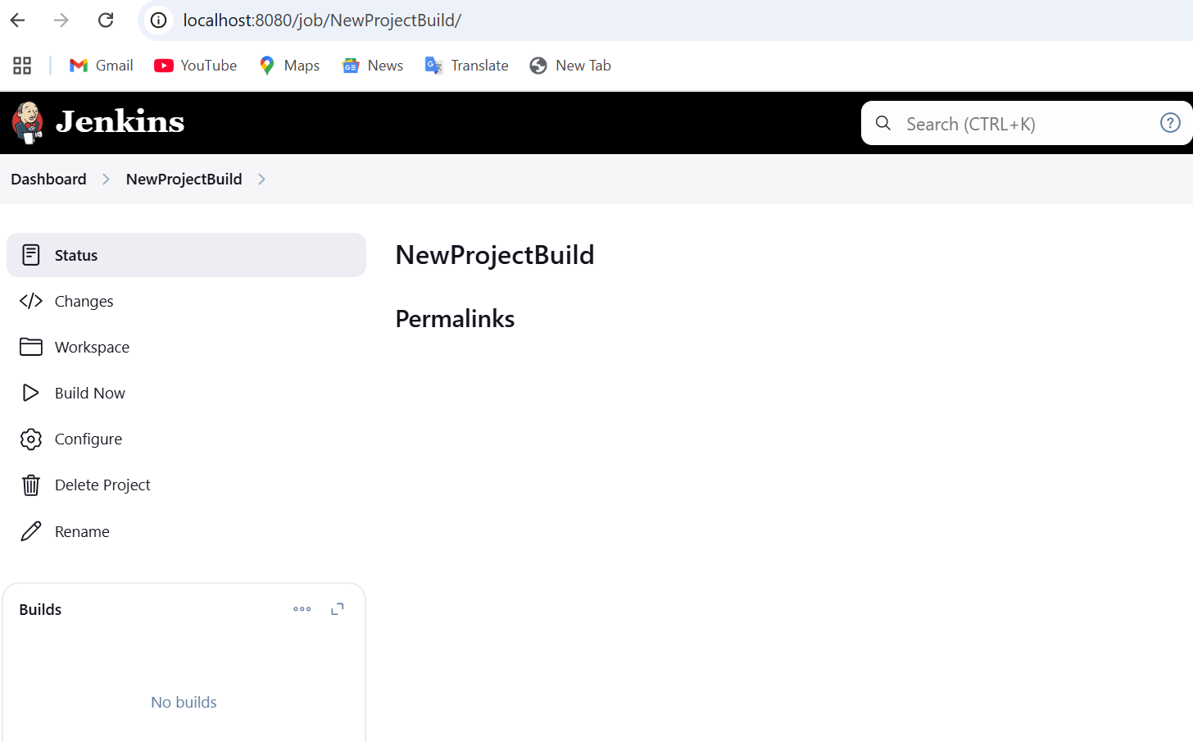

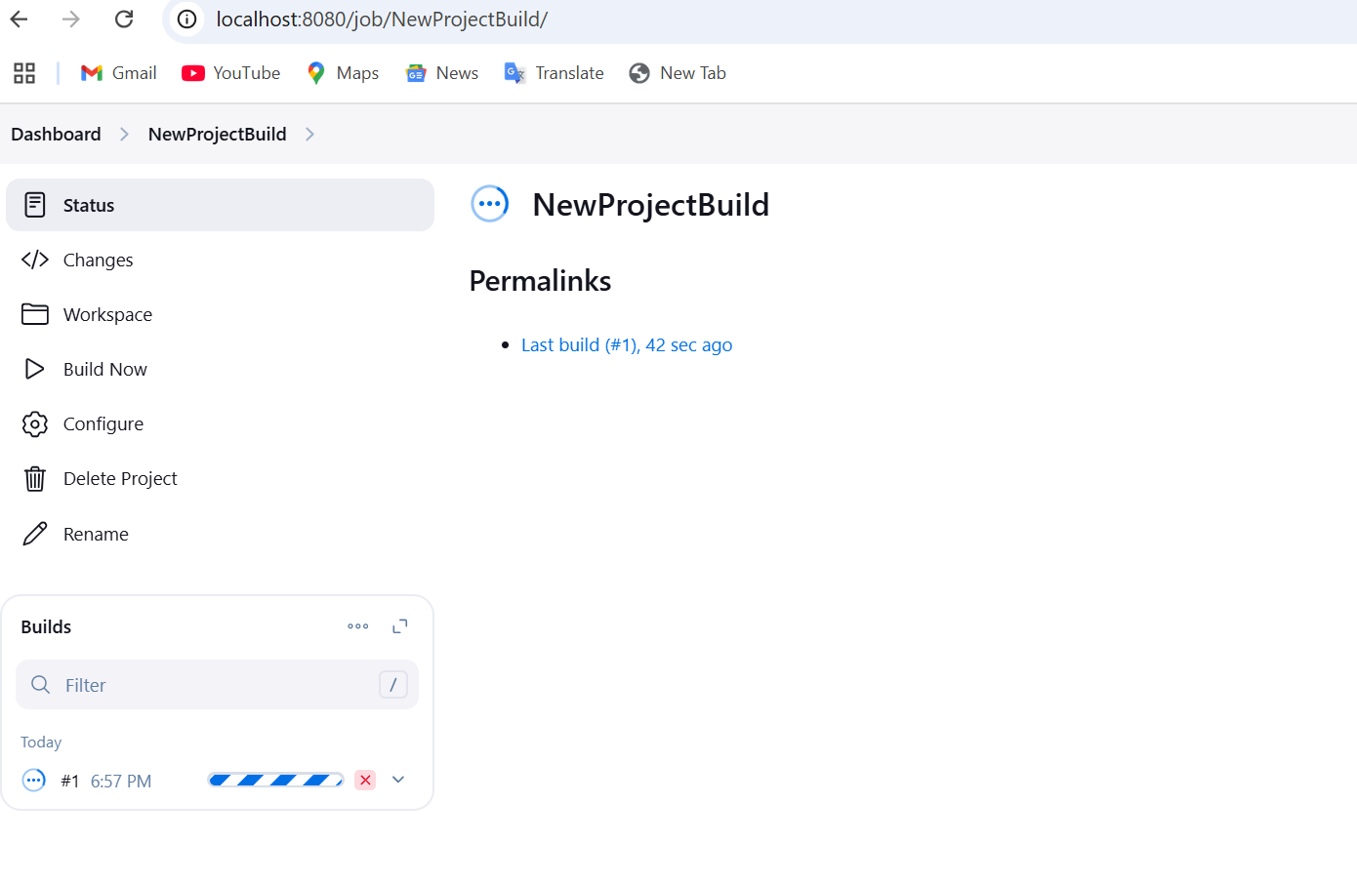

Check the console output

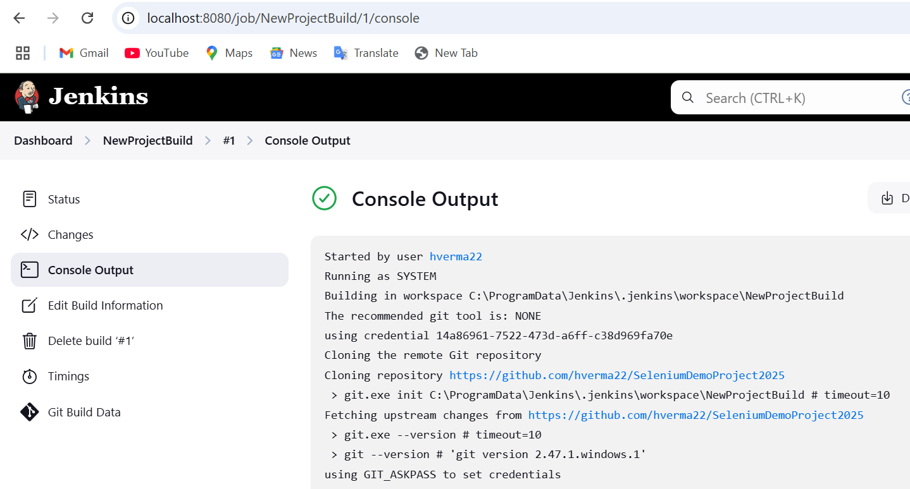

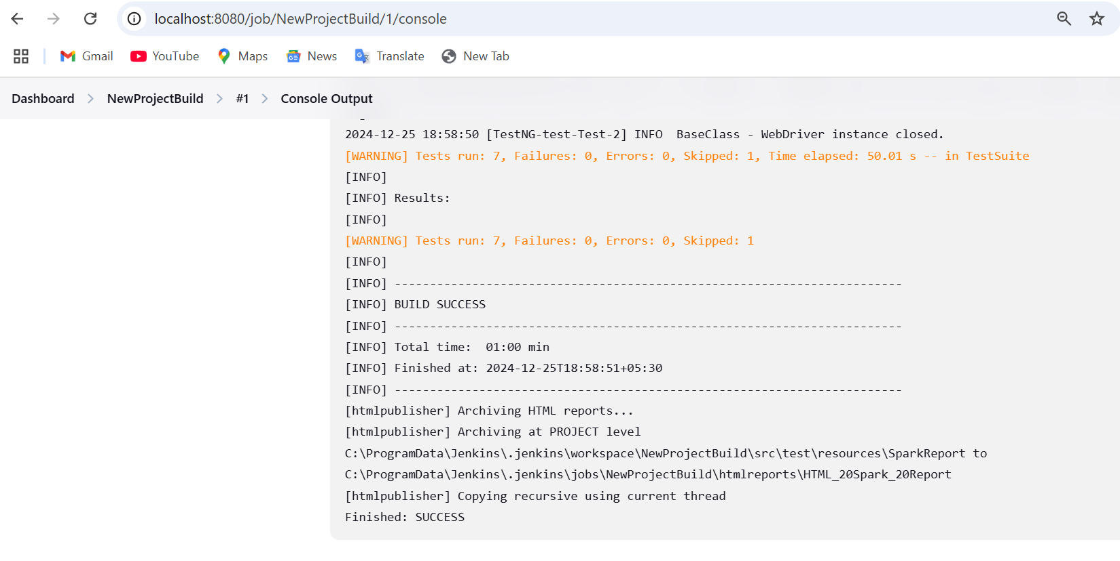

Verify the report

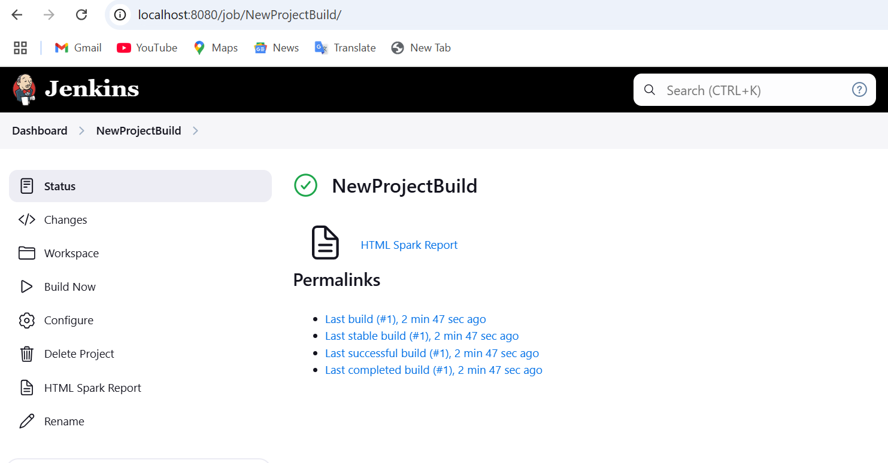

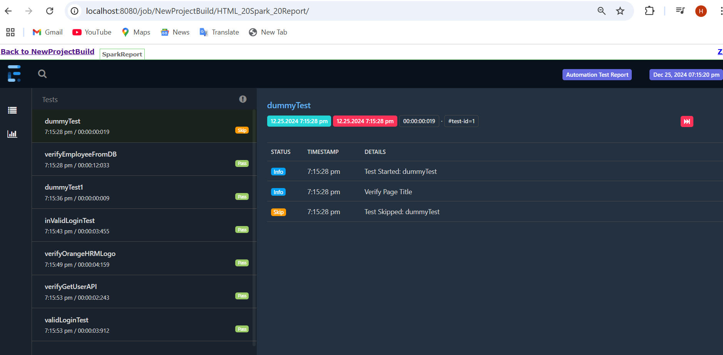

**Resolution of the below issues if you encountered**

1. If your report is broken like css is not working then use below script:

Navigate to <http://localhost:8080/script>

And run the script - System.setProperty("hudson.model.DirectoryBrowserSupport.CSP", "")

**Permanent solution:**

Go to your Jenkins path

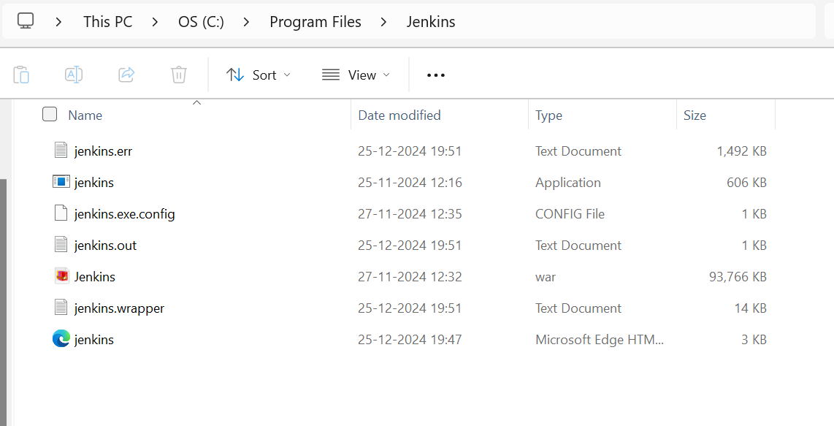

Open Jenkins.xml

add the following script to <arguments> tag

<arguments>-Xrs -Xmx256m -Dhudson.lifecycle=hudson.lifecycle.WindowsServiceLifecycle -Dhudson.model.DirectoryBrowserSupport.CSP= -jar "C:\Program Files\Jenkins\jenkins.war" --httpPort=8080 --webroot="%ProgramData%\Jenkins\war"</arguments>

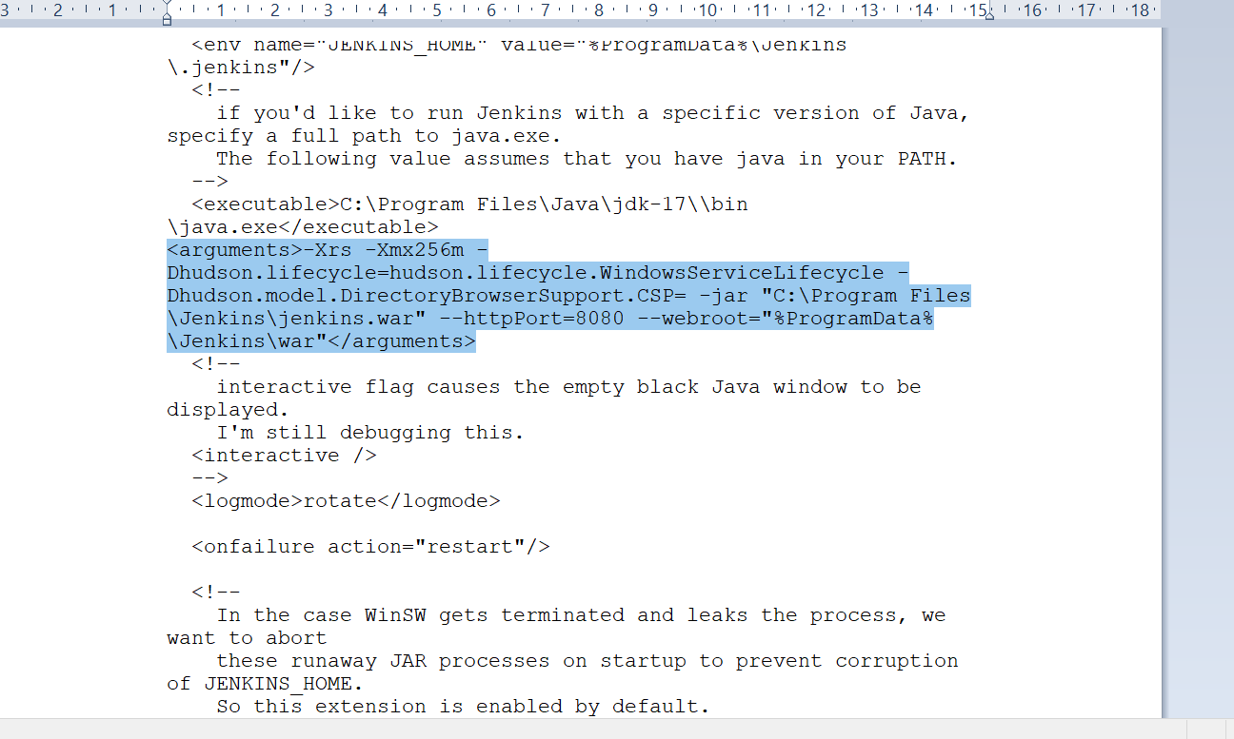

Save the file and close it

And now restart Jenkins server – you can do it from command prompt or from services

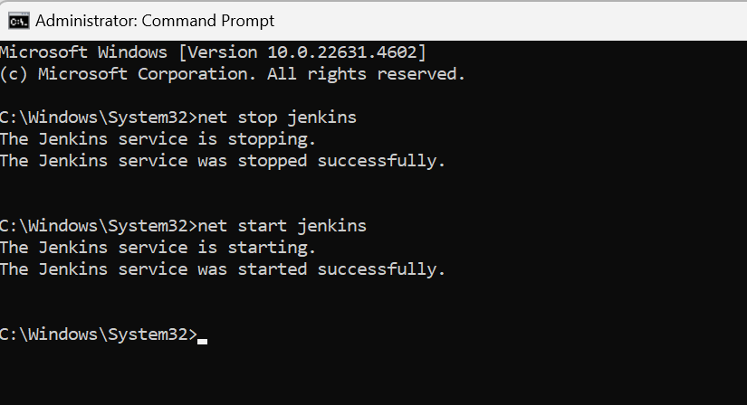

Right click and you can do start/stop from services

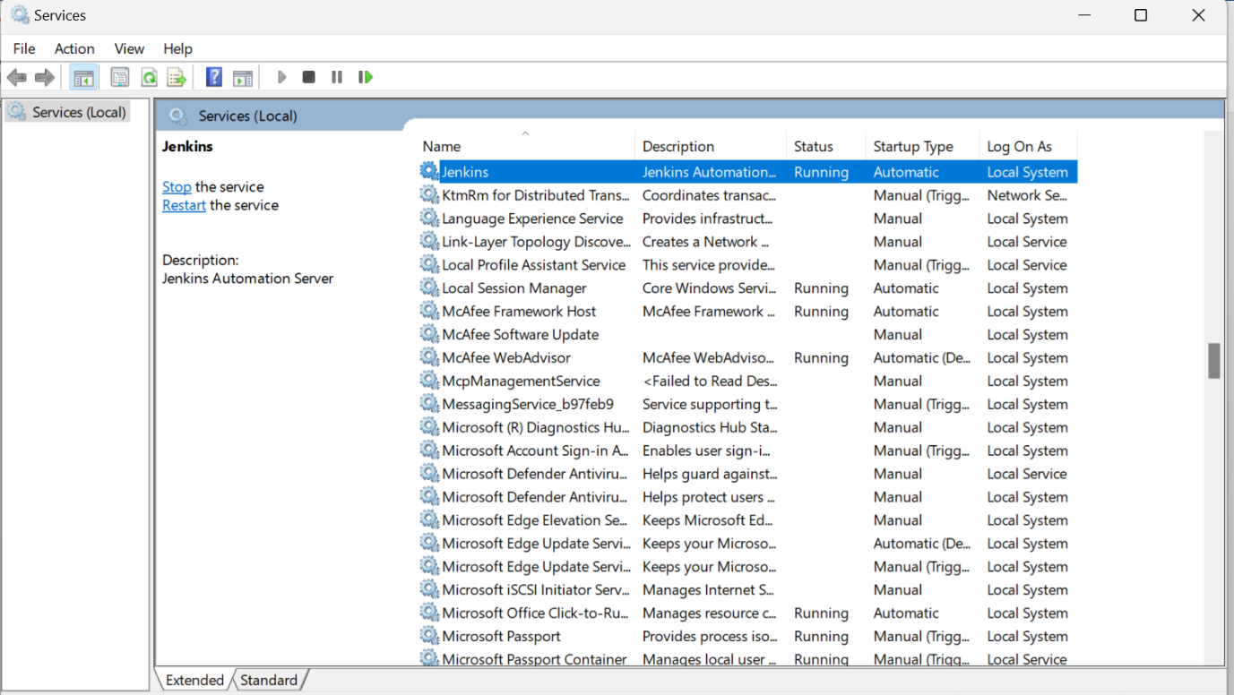

1. Problems if you get like below error while setup the build:

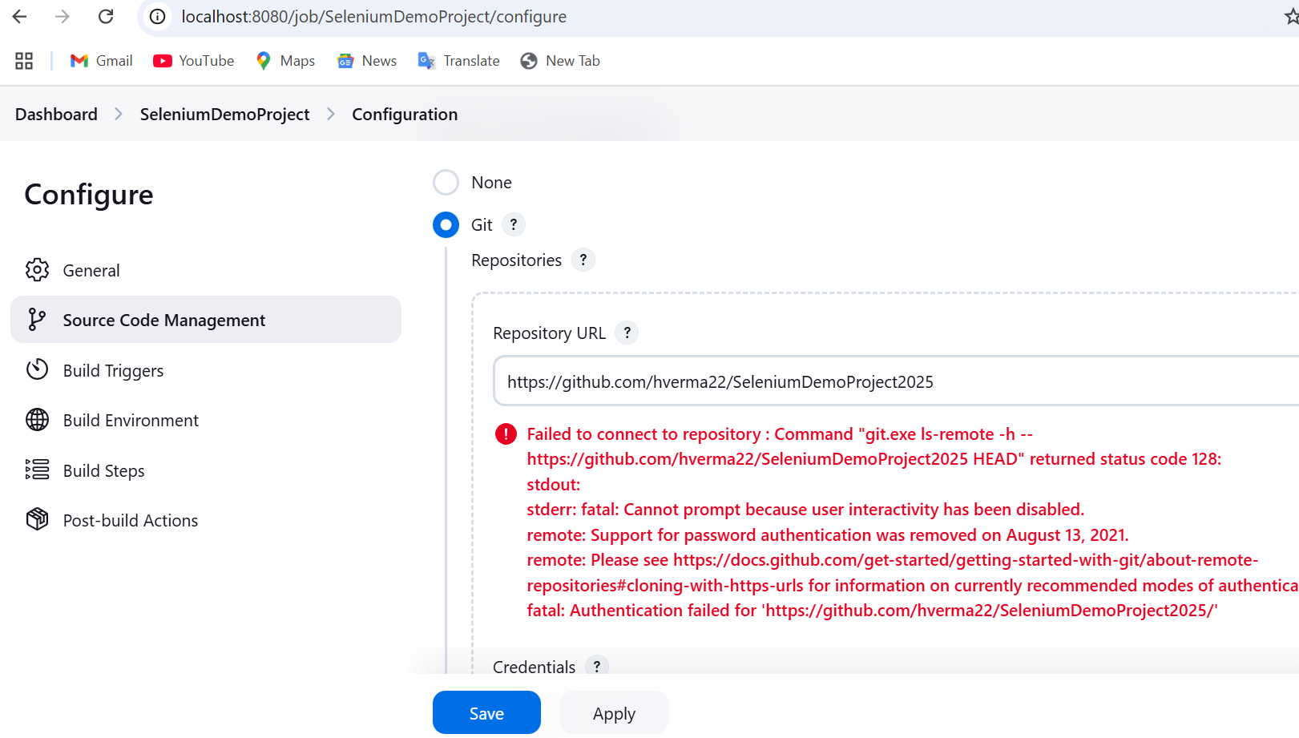

Run the following command from gitbash on your project directory

git remote set-url origin https://<your-token>@github.com/username/repository-name.git

